**National University of Computer & Emerging Sciences, Karachi  
Spring-2022 School of Computing (BSSE)  
Lab - Final Examination, Spring 2022 (Paper B)  
2nd June, 2022, 08:30 am – 10:30 am** Fast

|  |  |  |
| --- | --- | --- |
| **Course Code:** CL1004 | **Course Name:** Object Oriented Programming Lab | |
| **Instructors:** Mr. Zain ul Hassan, Ms. Abeer Gauher | | |
| **Student Roll No:** | | **Section:** |

**Instructions:**

READ carefully the following instructions before attempting the paper.

* Except your Roll No and Section, **DO NOT WRITE** anything on this paper.
* The Final Exam consists of **3 questions on 2 pages**. Make sure that you have all of these and that they are all legible.
* Read all questions and their instructions thoroughly before you begin. It is always worth your time to plan ahead!
* In case of any ambiguity, you may make assumptions but your assumption must not contradict any statement in the question paper.
* **DON’T** share your program, if your code is matched to any member of your class, both will get **straight F** in the course without asking who shared or who magically copied.

**Submission guidelines:**

* Submit the java file named as 211234_Q1.java, k211234_Q2.java for each question and submit them on Google Classroom.

**Time Allowed**: 120 minutes **Maximum Marks**: 50

**Question 01 [marks: 15] [Estimated Time: 30 minutes]**

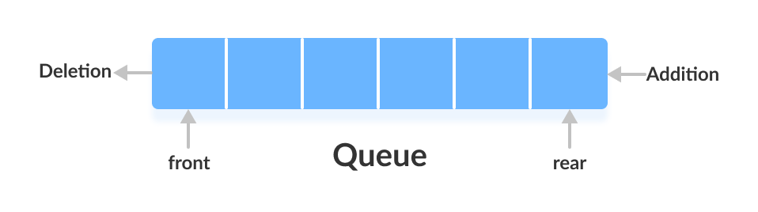As a Computer Science student, you are required to implement a Queue. Elements in a queue are added at the end and removed from the front as seen in the figure given below:

* Create a template class named “Queue”.
* The class has 3 attributes front, rear and capacity. It also has an array/ararylist.
* Create a parameterized constructor that takes capacity as an argument and sets it, initializes front and rear to 0 and also initializes the array/arraylist.
* Create a function add( ) that adds elements in the queue. To check whether the queue is full or not capacity and rear should not be equal. If they are equal display “Queue is full”, else add elements. Remember elements will be added at the rear.
* Create a function display( ) to display the elements in the queue.

In the main, create a queue of and add at least four elements

**Question 02**   **[marks: 15]** [**Estimated Time: 30 minutes]**

A bank management system is shifting its physical records to the computer. As a Java developer, you are required to develop a file-based management system for the bank.

The bank has the attributes account title, account type (savings or current), current balance (String).

Ask the user to input all the details. Show options to the user whether their account is savings or current and then write the appropriate account type in the file. If the account is Savings write “You get 5% interest each month” and if it’s Current write “You get no interest each month”.

Perform all the above for 2 users one for Savings and one for Current. Once all the information is written to the file, read all the information and display the details.

***Question 03* [marks: 20] [Estimated Time: 30 minutes]**

A school is implementing an automated exam and attendance system. Your services are required as a Java developer to make the required changes for the university. Implement the scenario given in the figure.

**Exam**

**Attendance**

Student

Grade_cal( )

Att_cal( )

1. The class Student has the attributes name, roll number, class. All are private members. Set and Get are required for all the attributes.
2. Make a parameterized constructor that sets all the attributes.
3. Each student has 4 subjects. Marks should not be equal or less than 0 and greater than 100, otherwise do not allow the user to proceed. Calculate the overall grade earned in the course. If total percentage of all the four subjects is greater or equal to 90 “A+”, greater or equal to 80 and less than 90 “A”, greater or equal to 70 and less than 80 “B”, greater or equal to 60 and less than 70 “C”, greater or equal to 50 and less than 60 “D” or else display “Failed”.
4. Students should have atleast 70% attendance. Total number of classes in a semester are 45. Calculate the percentage of attendance and if it is less than 70, display “You are not eligible to sit for the exam” else display “You are eligible to sit for the exam”. Classes attended should not be 0 or less and do not allow the user to proceed until the condition is satisfied.
5. The class has a function details( ) that displays all the details of the students.
6. Demonstrate all the functionality in the main program.

***Best of Luck ☺***